- Click on search icon in down left corner and find “Task Scheduler”
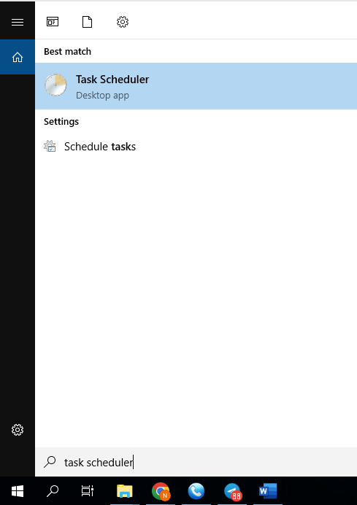
- In pop up window right button click on empty space and choose “import Task”
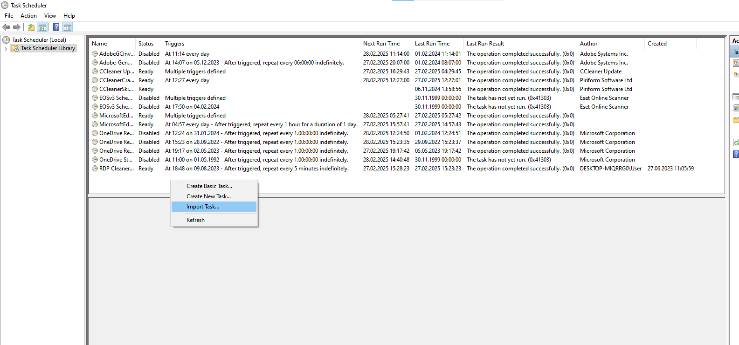

- Find your file called “Cleare_time_startup_v2.xml” choose it and press “Open”
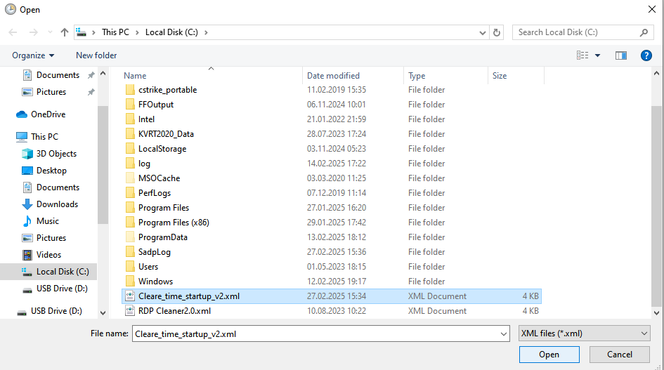
4.in pop up window click on “Change User or Group”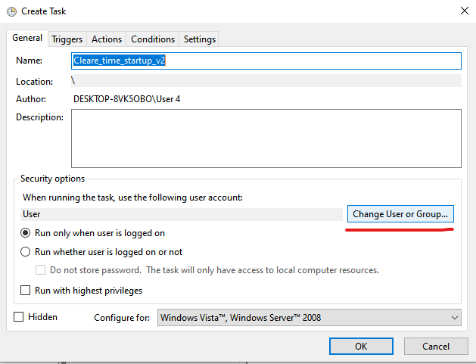
5. In pop up window write your PC user name (by default it “User”)
and press on button ”Check Names”
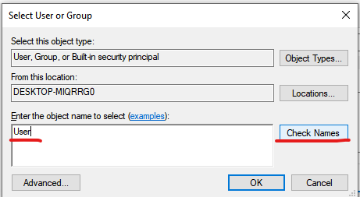
(you can find your PC user name by pressing on “Start” and check it here)
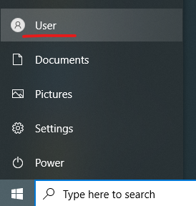
6. Then go to “Actions” tab, chose your action and press “Edit”
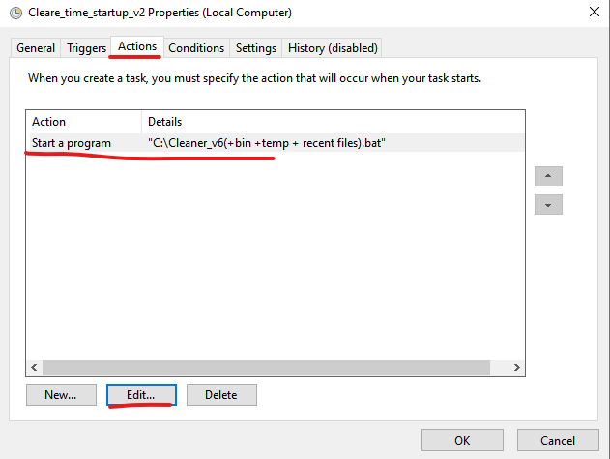
7. In pop up window press on “Browse” and find your file called
“Cleaner_v6(+bin +temp + recent files).bat” and press “Open”
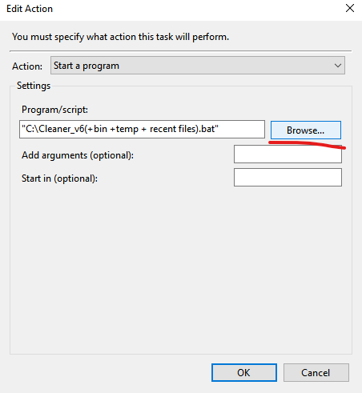
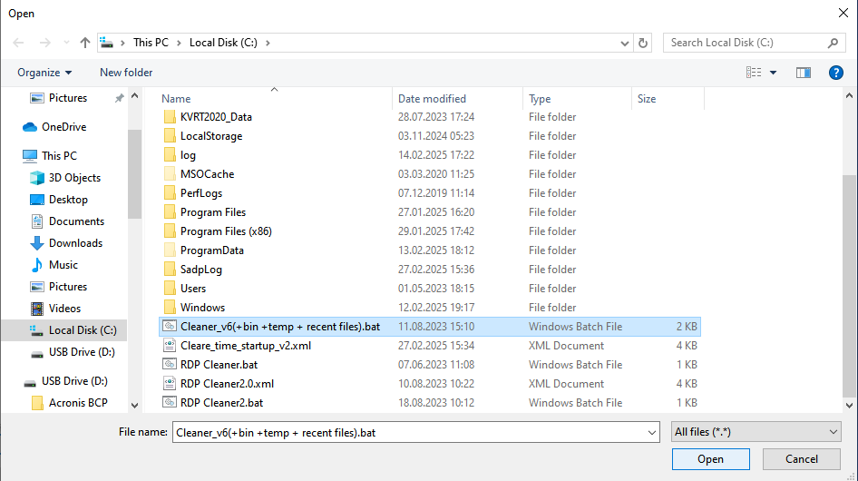
8. Then press “OK” on opened windows
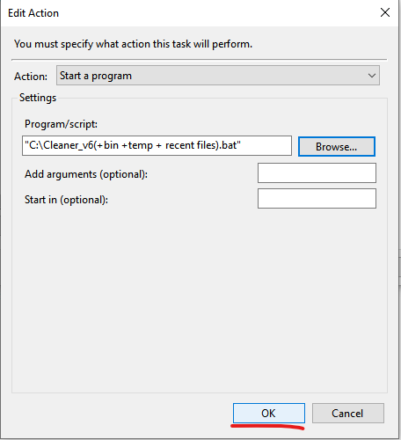
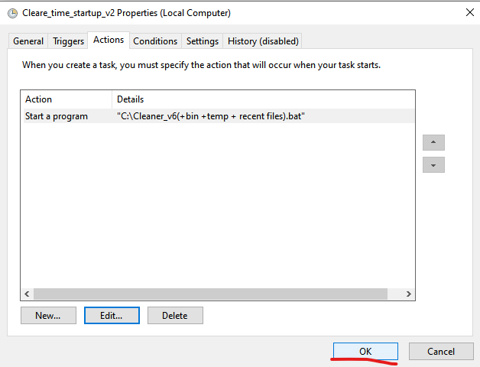
First script is added
9. Again, press on empty space and choose “Import Task”
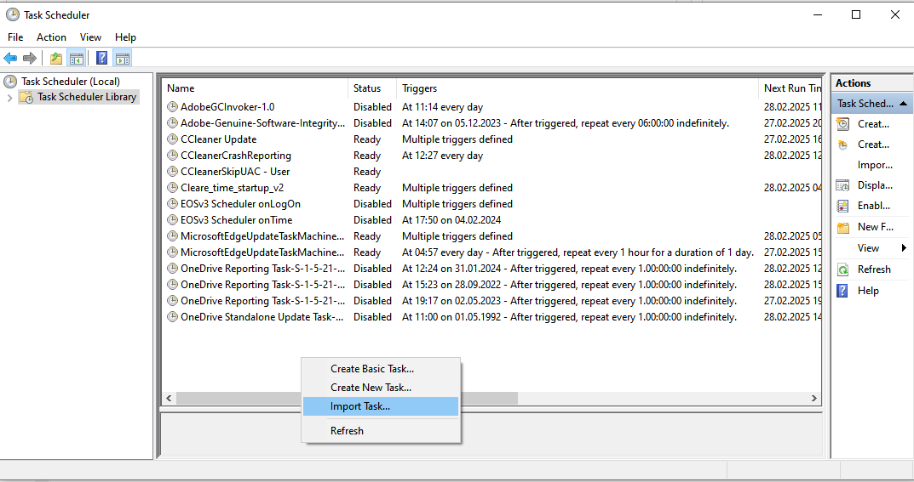
10. Now find file “RDP Cleaner2.0.xml” and press “Open”
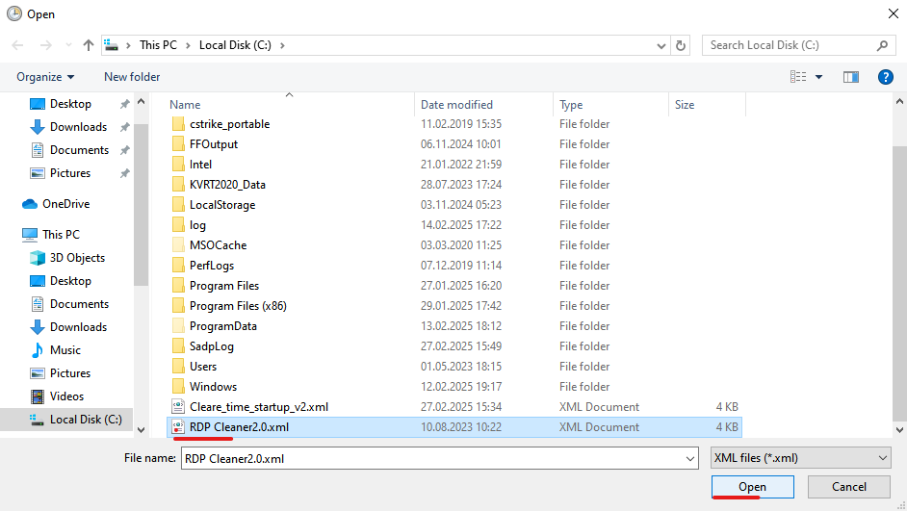

11. In pop up window click on “Change User or Group”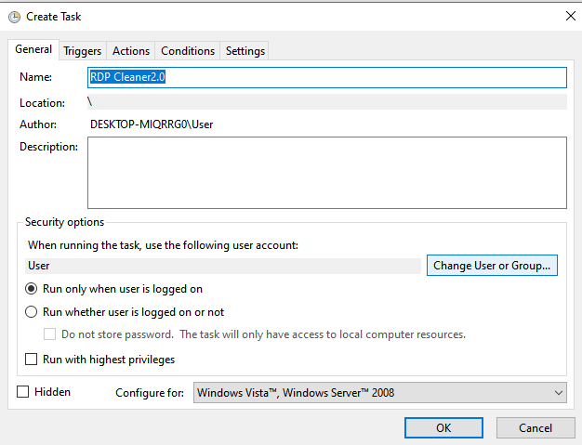
12. Write your pc user name and click on “Check Names” and then press “OK”
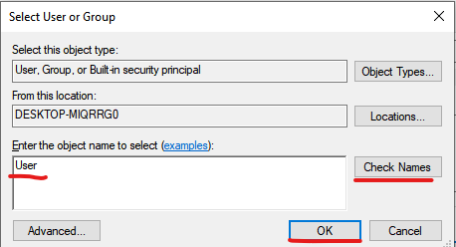

13.Go to “Actions” tab, chose your action and press “Edit”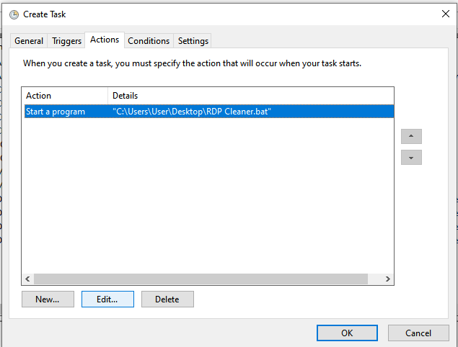

14. On pop up window click on “Browse” and find your file called
“RDP Cleaner2.bat” and press “Open”
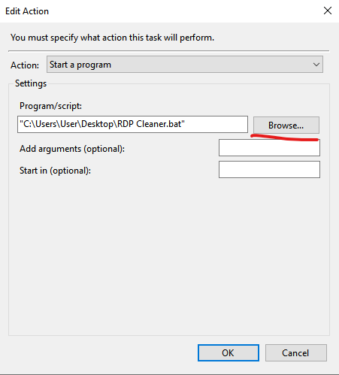
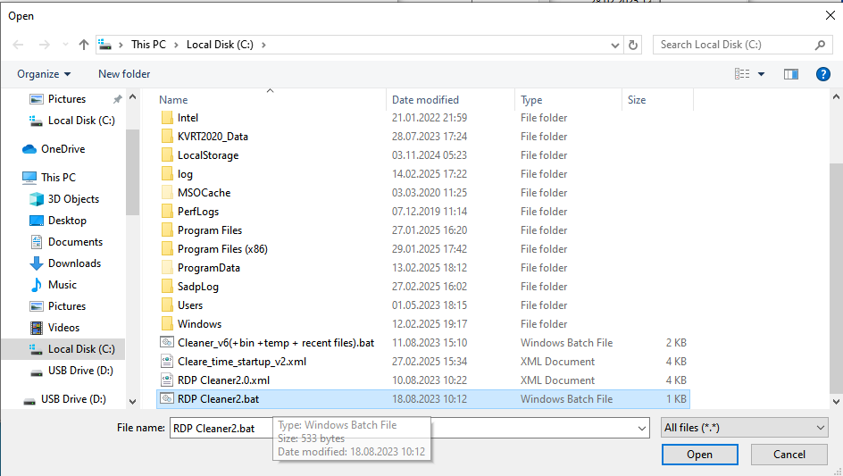

15. Press “OK” on opened windows
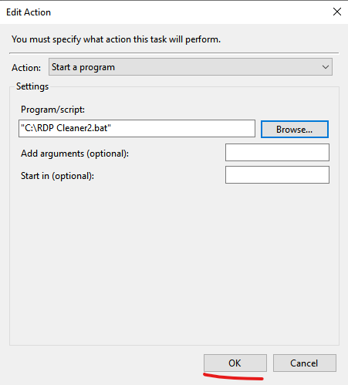
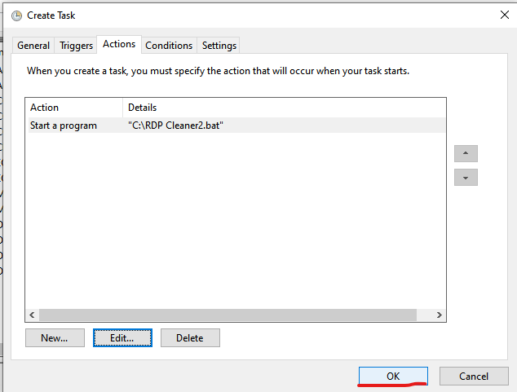
Both scripts are added

